**How to install and use the USS .dat File Tool**

The following guide demonstrates how to install and use the USS .dat File Tool for help with testing and analyzing download files.

**Step 1.** Installation

To use the tool, simply download the Python programming language from [www.python.org/downloads](http://www.python.org/downloads) to install it.



**It is important to ensure that “Add Python 3.X to PATH” is checked during installation.**

This allows the program to run at the command line without issues.

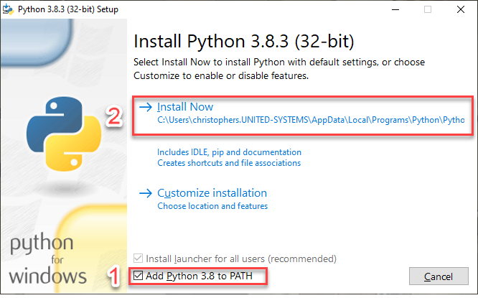

**Step 2.** Running the Program

After installation, we can ensure that the program is working properly by simply double-clicking on the tool. It should open a command prompt window like the picture shown below.

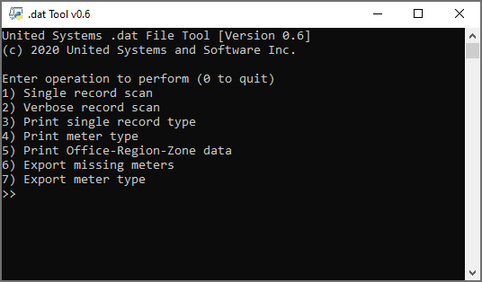

**Step 3.** How to use the tool’s features

**Before using the program, ensure that the download file you would like to scan is in the same directory as the tool**. The tool looks for any file named ‘download.dat’ and uses that by default. Below is a quick description of each operation the tool can perform.

1. **Single record scan**: Searches for the number of instances of a single type of record within a download file. An example would be searching for the number of RHD records, shown below.

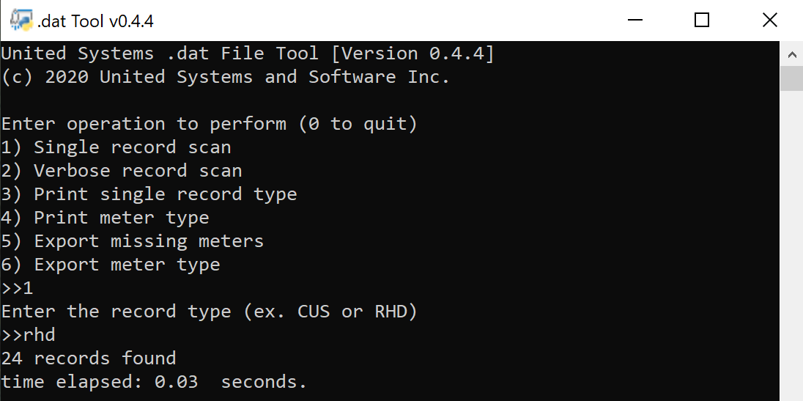

1. **Verbose record scan**: Searches the entire download file and print the number of the most common types of records.

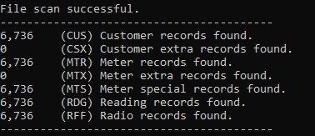

1. **Print single record type**: Prints every instance of a specified record to the console.

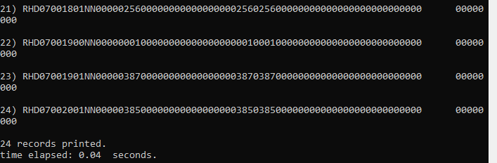

1. **Print meter type**: Prints the customer record for every customer who has a specified meter type in the RDG record.

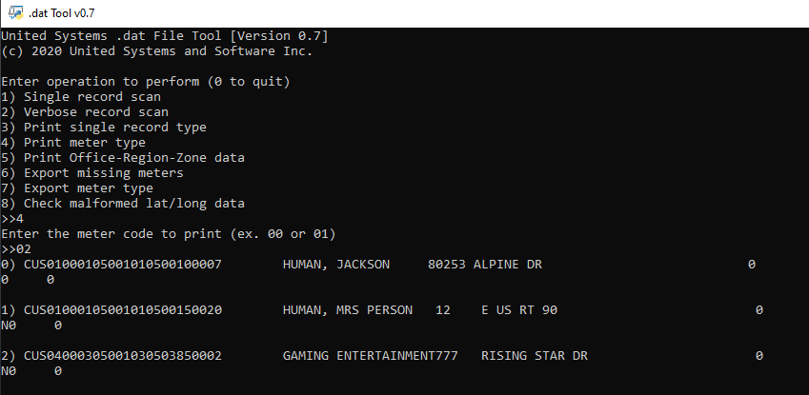

1. **Print Office-Region-Zone data:** Finds the first instance of Office-Region-Zone fields in the file and prints them to the console.

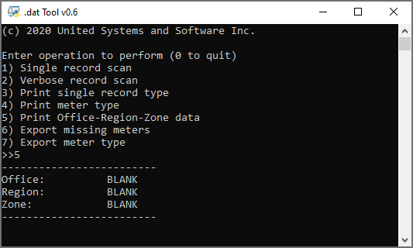

1. **Export missing meters**: Searches the download file, finds every instance of a missing meter type, then exports the associated customer record to a text file in the same directory. An example text file is shown below.

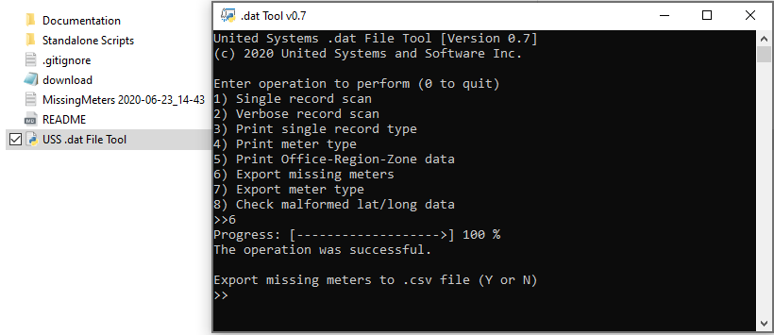

**Once the text file has been exported, the user is given the option to export the same list of customers as a .csv** file for easy sorting. An example of such a file is shown below.

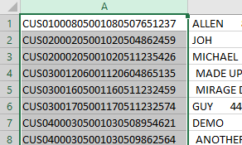

1. **Export meter type**: Searches the download file and exports the customer record of every customer who has a specified meter type in the RDG record to a text file.

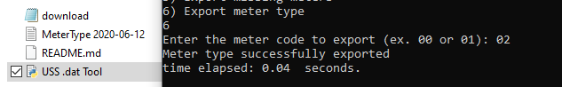

For example, we want to find every customer with a meter number ‘02’, so we export that meter type, and this is the text file we get:

